Part 2: Testing Household Products
Step 1
Household product | Volume of household product | Volume of indicator | Observation (observed colour) | Estimated pH
Lemon Juice | 15 mL | 5mL | Purple | 4
Tap water | 15 mL | 5mL | Blue | 7
Egg White | 15 mL | 5mL | Green | 10
Laundry powder dissolved in water | 15 mL | 5mL | Green-Yellow | 12
White vinegar | 15 mL | 5mL | Red | 2
Soap | 15 mL | 5mL | Blue | 9
Cream of tartar | 15 mL | 5mL | purple | 3
Bicarbonate soda | 15 mL | 5mL | Blue | 8

Step 2: Images
Lemon Juice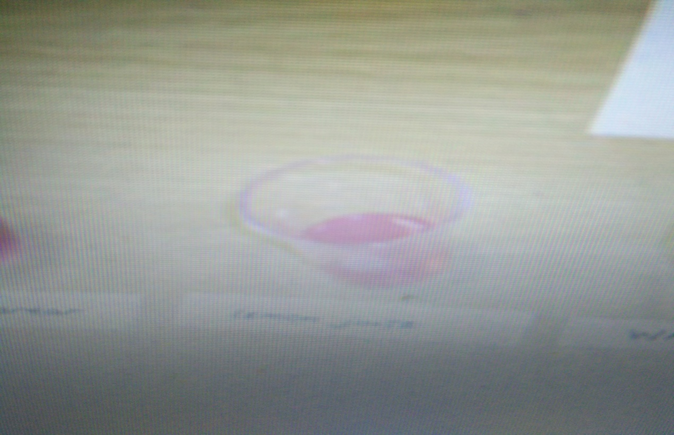

Tap water
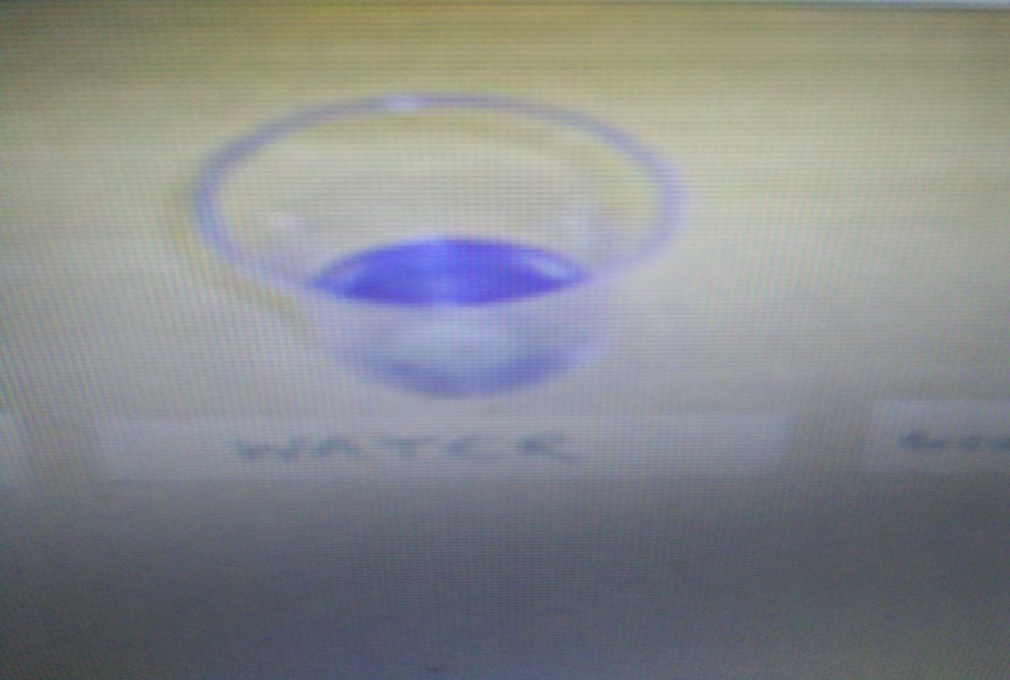

Egg White
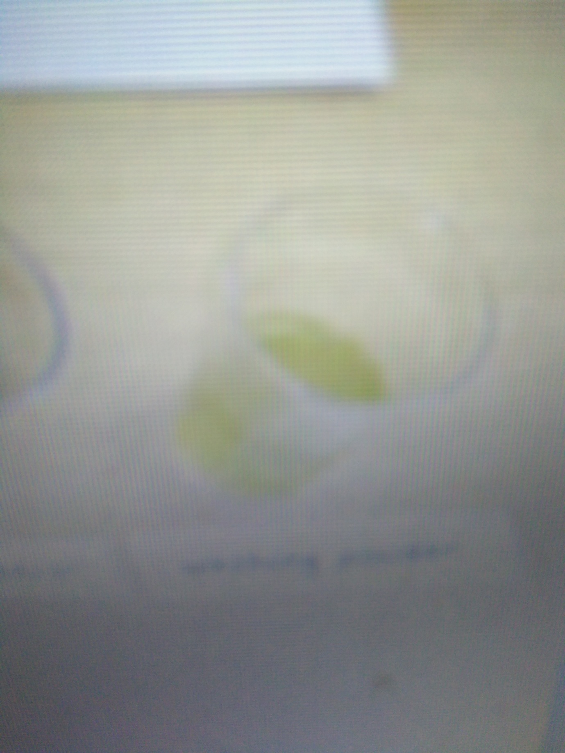

Laundry powder dissolved in water

White vinegar
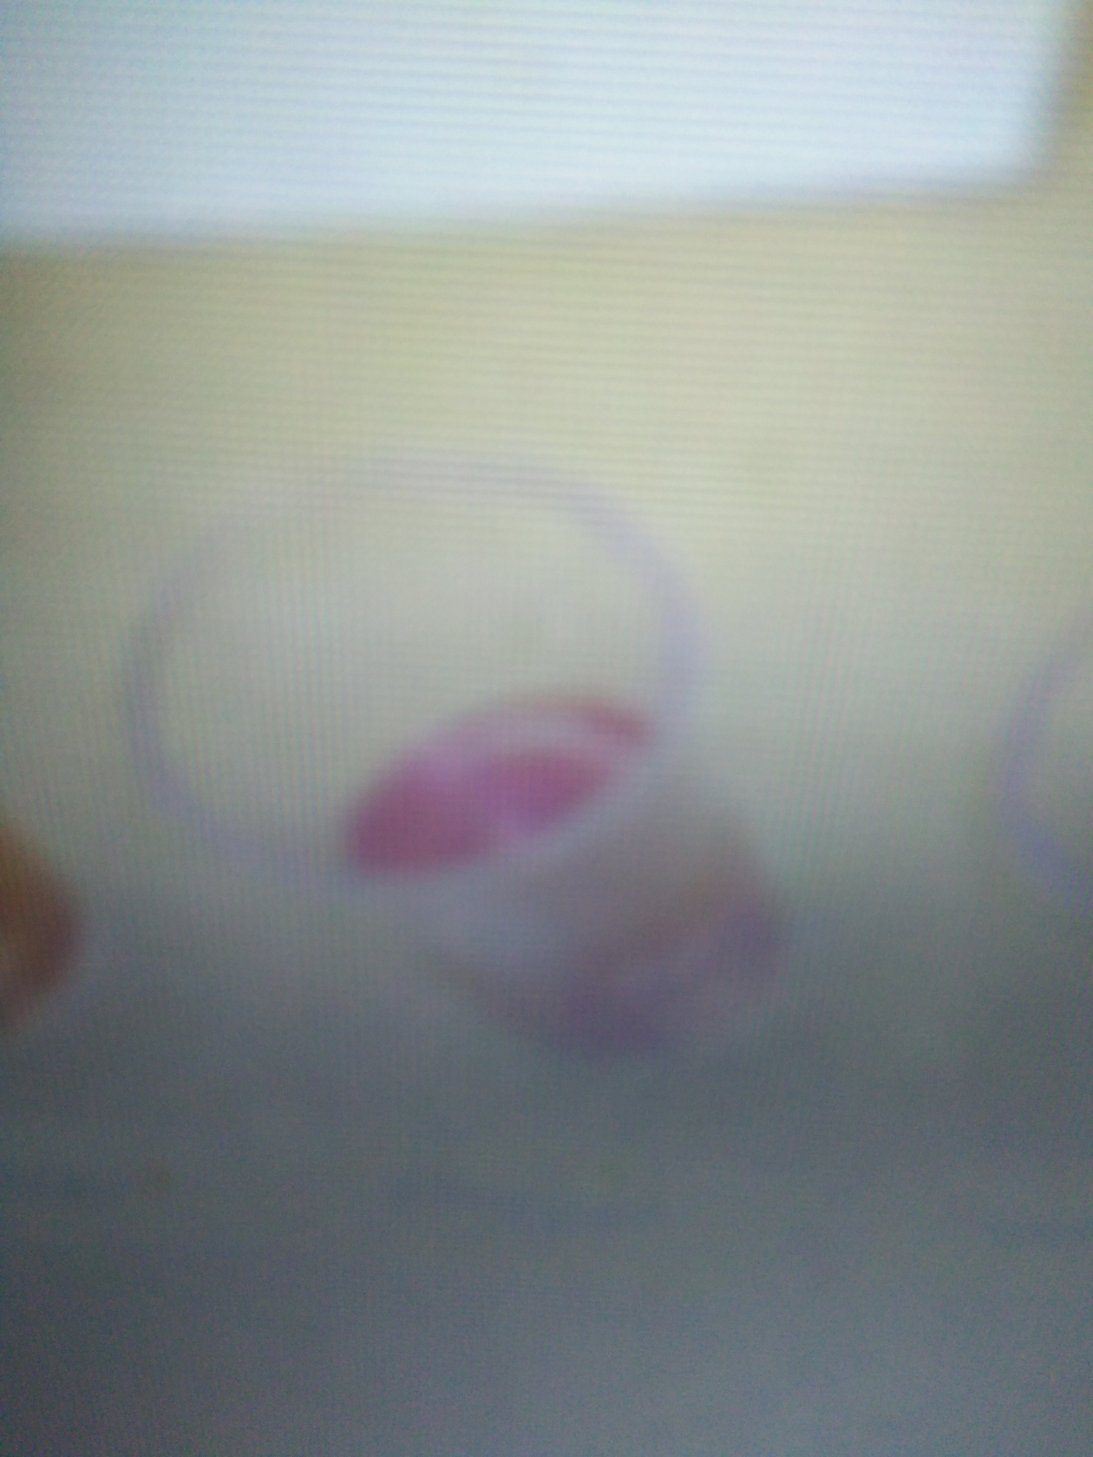

Soap


Cream of tartar
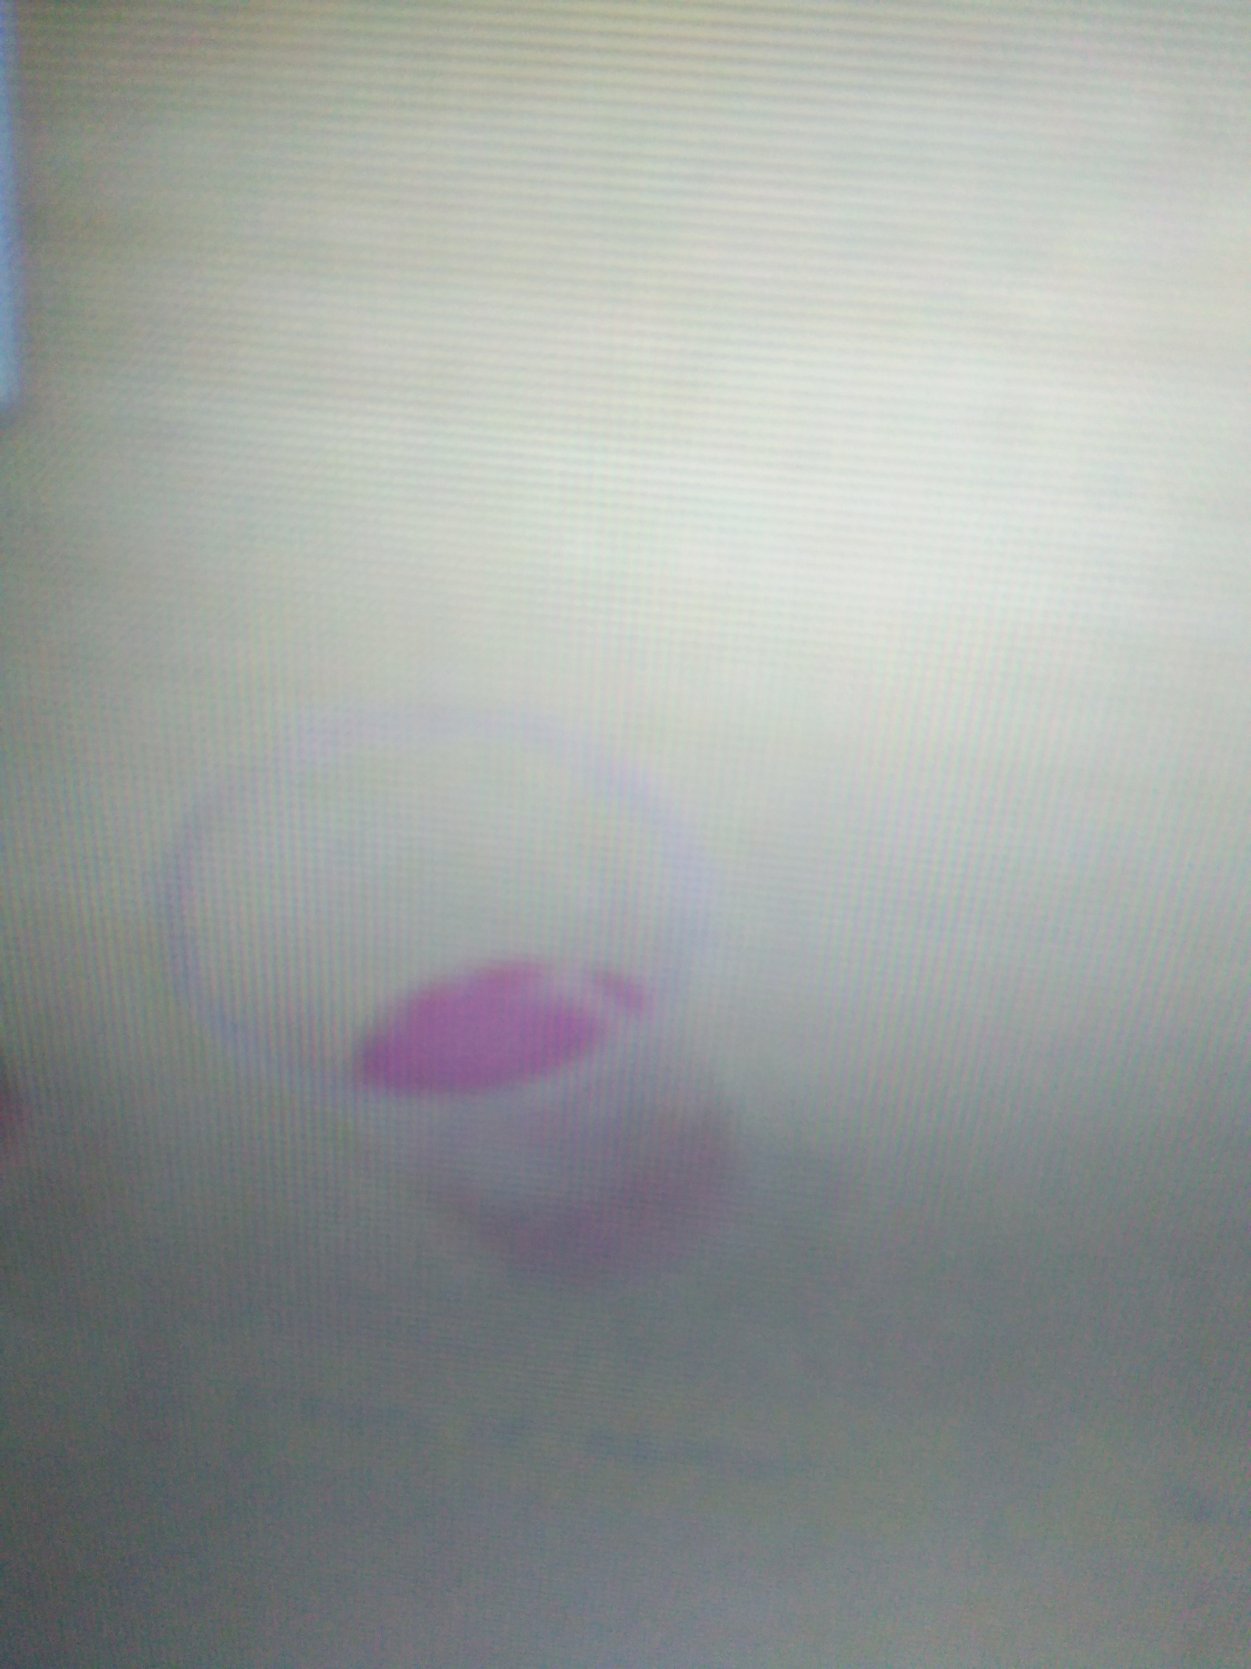

Bicarbonate soda
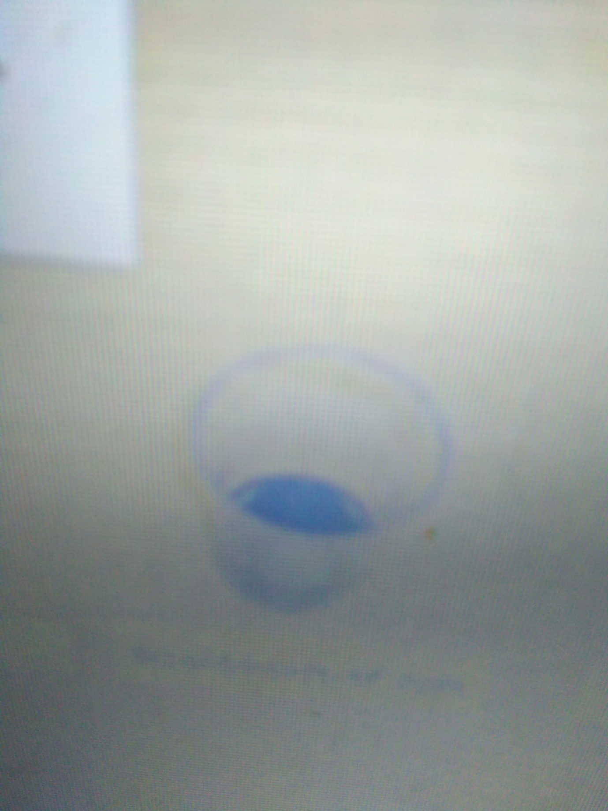

Part 3: Neutralization of Acid and Back Again
Step | Substance Added | Observation (e.g. colour)
- vinegar | Bicarbonate soda | Blue
- bicarbonate soda | vinegar | Blue
- Re-acidification | Vinegar | Red

Additional Questions
Q1. (a). White vinegar with an estimated pH of 2
(b) [H₃O⁺] = 10^{-pH} = 10⁻² = 0.01 mol/L
Q2. (a) Acidic solutions is form X
(b) Neutral solutions is form Z
(c) Alkaline solutions is form is form Y
Reasoning: Form X has an extra proton which makes it acidic
Form Z has neither an extra proton nor hydroxyl ions thus making it neutral
Form Y has one less proton making it have an extra hydroxyl ion thus alkaline
Q3. Based on observations made in part 3, the indicator molecule can reversibly change from one form to another and back again. This can be told by the colour change of indicator. When sodium bicarbonate was added to vinegar, the colour of the indicator changed from red to blue. And when an excess of vinegar was added to the blue solution, the colour of the indicator changed back to red because of the increase in the hydronium ions in the solution.
Q4. CH₃COOH(aq) + H₂O(l) ↔ CH₃COO⁻(aq) + H₃O⁺(aq)
Q5. K_{a} = [CH₃COO⁻ ][H₃O⁺] / CH₃COOH
Q6. It favours the reactants.
Q7. Acetic acid is a weak acid. The small Ka value indicates that acetic acid partly dissociates in water thus is a weak acid.
Q8. CH₃COOH (aq) + NaHCO₃(aq) CH₃COONa(aq) + CO₂(g) + H₂O(l)

